NCaeyc is delighted to invite vendors to our 2017 64th Annual Conference
2014 Annual Conference!

September 14-16, 2017
Raleigh Convention Center (RCC)
500 S Salisbury St ∙ Raleigh, NC 27601
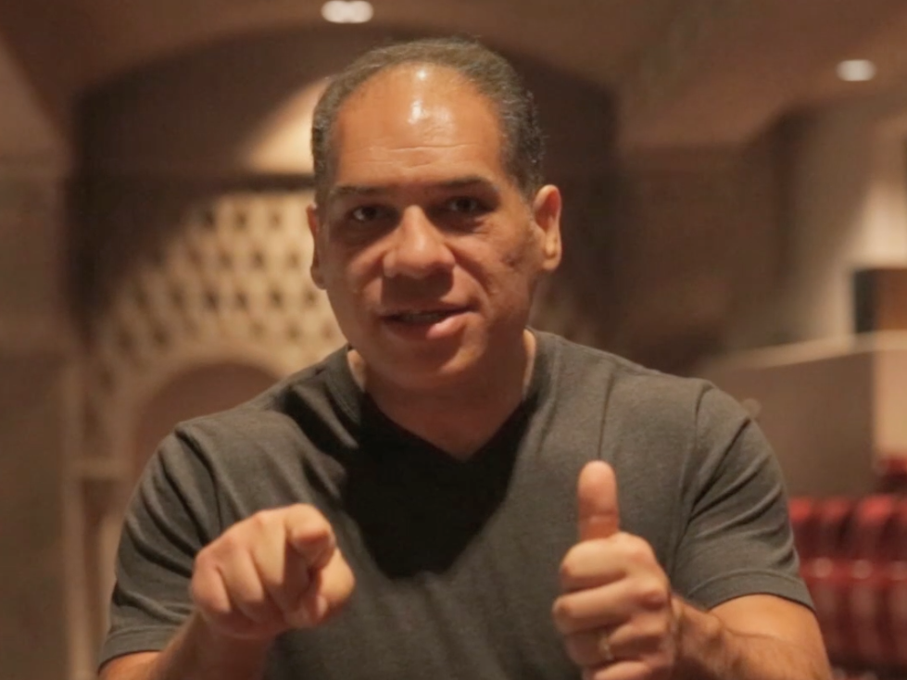
Keynote on Friday with Enrique Feldman
NCaeyc takes the vendor
experience to a whole new level!

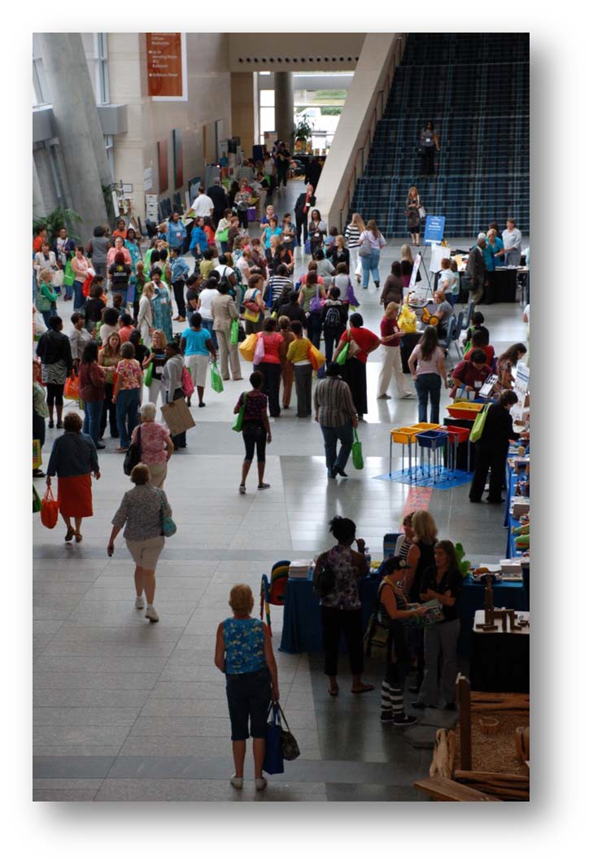

We want YOU to be a part of it this year!
Displays in Hallways for High Visibility & High Traffic
With 30 minute breaks between Sessions to provide time for attendees to visit your booth!
                - All conference sessions in RCC put you right in the center of the attendees’ experience
                - “Vendor Spotlight” Friday, 4:30 pm with opportunities for you to have a “Minute at the Mic” to talk about your company and product!
                - Exhibitor area opens at 8 am on Saturday with sessions beginning at 9 am giving attendees time to visit with you!
Please complete the vendor application on the next page TODAY to reserve your space. Contact Chris Butler at 919-510-5034 or cbutler@ncaeyc.org if you have any questions.

Setup: Thursday, Sept. 14th 7:00am‐6:00pm Exhibition Hours: Thursday 11:00 – 3:00 (optional)
Friday, Sept. 15th 8:00am‐5:30pm Saturday, Sept. 16th 8:00am‐1:00pm
Breakdown: Saturday, Sept. 16th 11:30am‐1:30pm

North Carolina Association for the Education of Young Children
an affiliate of naeyc
182 Wind Chime Court Suite 104, Raleigh, NC 27615
919‐510‐5034 (p) 919‐510‐5033 (f) www.ncaeyc.org
Vendor Pricing and Application

Exhibit space will be located in the hallways outside the session rooms throughout the
Raleigh Convention Center to provide high visibility and high traffic!

Set-Up: | Thursday, September 14 | 7:00 am-6:00 pm
Exhibition Hours:  Break-Down: | Thursday, September 14  Friday, September 15  Saturday, September 16  Saturday, September 16 | 11 am-3 pm (optional)  8 am-5:30 pm  8 am-1pm  No earlier than 11:30 am; completed by 1:30 pm
Please Note: Exhibit space must be staffed during the times the Vendor areas are open.
On Saturday, no part of any exhibit may be dismantled prior to 11:30 am, but must be dismantled no later than 1:30 pm.

Exhibitor Space  Includes one 8’x24” draped table and 2 chairs | Cost of 1st table/ 2nd/ each additional
Main Level 3 - Front Entry Hall | $475\$435\$410
Main Level 3 – Hallway Outside Session Rooms | $450\$410\$385

To reserve a space, first refer to table layout to identify your preferred space(s).
Complete this form and submit to NCaeyc at 182 Wind Chime Court, Suite 104, Raleigh, NC 27615
To reserve a table(s), application forms must be accompanied by a $100 per table deposit or full payment no later than August 1st. Payment in full is required no later than August 17th.

Company Name:

Contact Person(s):

Company Representatives on site: _____________________________________________________________________

Address: __________________________________________________________________________________

City: _________________________________________ State: Zip: ______

Contact Phone: Contact Phone #2:

Email: _____________________________________ Website address ____________________________________________

Products to be exhibited:

Amount of enclosed check: ___________ Check #: Total number of tables requested:

Requested Table Number(s) (See map of layout of RCC for table numbers):
(If your choice is not available, NCaeyc will contact you to discuss alternate availability.)

1st Choice(s): 2nd Choice(s):

I am interested in placing an ad in the program: YES! MAYBE
I am interested in learning more about SPONSORSHIP and ADVERTISING opportunities: _YES! MAYBE
I am interested in offering a DOOR PRIZE so we REALLY get noticed during VENDOR SPOTLIGHT: _YES! MAYBE

For more information please contact Chris Butler at 919-510-5034 or cbutler@ncaeyc.org.

Refund Policy: A refund may be granted if NCaeyc receives written notice of cancellation14 days prior to the Conference and if we are able to resell your space.
Raleigh Convention Center Vendor Table Layout
All exhibitor spaces are located in the hall areas outside the session rooms on level 3.
Prices and table space descriptions are on the Application Form.

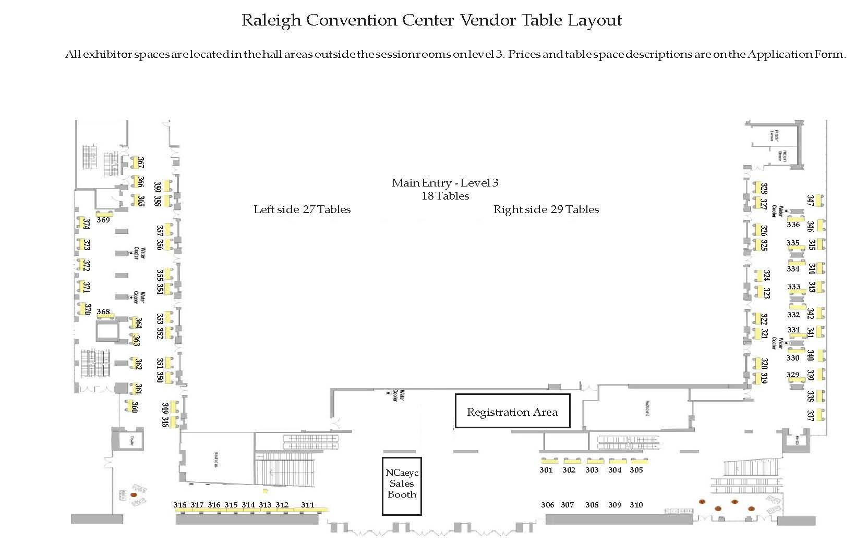

Advertising and Sponsorship Opportunities

Make a solid connection with attendees during and beyond their Conference experience!
Make sure your company’s name and information is at their fingertips!

Place your Conference Program ad today!
We put emphasis on our printed materials to maximize your marketing exposure!

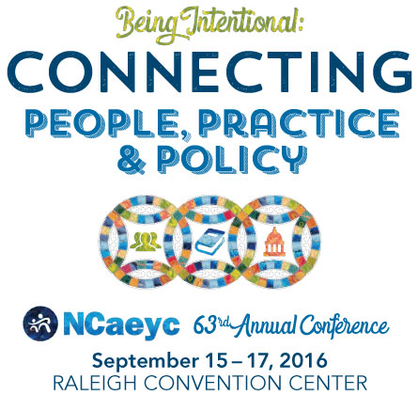

Place YOUR Conference Program Ad to make a lasting impression!

Advertisement

Ad images must be high-resolution PDF or JPG files.
Sizes are: Quarter Page = 4.25x5.5 Half Page = 8.5 x 5.5 or 4.25 x 11 Full Page 8.5x11
Small ad (1/8 of page) | 3.5” x 2.25 | $ 75
Quarter Page | 3.5” x 4.5” | $150
Half Page (vertical format) | 3.5” x 9” | $250
Half Page (horizontal format) | 7” x 4.5” | $250
Full Page | 7” x 9” | $450
Inside Back Cover | 7” x 9” | $500
Inside Front Cover | 7” x 9” | $550
Outside Back Cover | 7” x 9” | $600

Learn about SPONSORSHIP and AD OPPORTUNITITES! Connect with NCaeyc’s Executive Director, Lorie Barnes TODAY!
(919) 510-5034 or lbarnes@ncaeyc.org.

There are Sponsorship Levels and Ad Sizes to fit EVERY budget!
Demonstrate your commitment to excellence in early care and education.

Here is what vendors said about their experiences at NCaeyc’s Annual Conference:

“Great traffic flow and visitation at our booths!”

“Very accommodating staff, nice space, and good amount of traffic.” “Vendor Spotlights were fun for EVERYONE!”
“The hospitality was amazing…
staff worked hard to make sure all of our needs were met.”
“The people who were in charge were AWESOME! Way to go NCaeyc!” “Thank you NCaeyc for the kindness shown to Exhibitors;
We TRULY felt we were important to you!”

“NCaeyc’s efforts to support vendors were way over the top –
better than any other conference.”

“I called my company President during the Conference because I was SO EXCITED
about the wonderful experience we were having!”

What will YOU say this year?
Contact Chris Butler at 919-510-5034 or cbutler@ncaeyc.org

Raleigh Convention and Conference Center
Utilities Order Form

Connection:
1. Under no circumstances shall anyone other than the Convention Center Electrician make electrical connections to the Convention Center distribution system.
2. Hourly fees may apply for special wiring requirements.
3. Sharing power between booths is prohibited.
4. Convenience outlets that may exist in or near your booth are not included in your booth rental and may not be used.
5. All equipment provided by exhibitor must comply with all National Electric Codes as well as, state, local and international safety codes.
6. The building engineer may refuse service to any requests deemed unsafe.
7. No two-wire (home-use) extension cords are allowed.

120/208v and 277/480v Power:
The Convention Center can provide power for your equipment and machinery with the following limitations:
We can only guarantee that we will be able to provide power if you order in advance. Not all locations of the building have access to higher amperage or voltage power. Please discuss your needs with Jimmy Pierce at (919) 996-8526. We generally can provide the power you need for most equipment, however, we do not stock all types of outlets. If you need to plug into something other than a standard 120 or 240 volt, 20 or 30 amp outlet you need to either bring an outlet of the correct type or provide equipment with bare wire leads that we will install into our breaker panel. We will not disassemble your machinery or equipment in order to wire it. Please provide equipment with either a plug or bare wire leads.

Right of Way and Access:
1. The Convention Center reserves an easement behind each exhibit booth for the purpose of distributing electrical service to neighboring booths.
2. Unless otherwise directed, Convention Center electricians are authorized to cut floor coverings to permit installation of service.
3. Wall, column and permanent building utility outlets are not a part of the booth space and are not to be used by exhibitors without advance approval.
4. Access to floor boxes is strictly prohibited.
5. Displays and service panels must be available and accessible for inspection at all times.

Phone lines:
You will be provided with one phone line with an RJ-12 plug for each phone line you order. The phone lines are analog lines
suitable for use with computer modems, credit card machines, or for voice communication. If you want to use the line as a normal phone, you may rent the telephone set from us for an additional fee or bring your own telephone set. If you are using the line for a modem or credit card machine, you must program your device to dial 9, pause, and then dial the number you are calling. The phone lines are disabled from making international calls or dialing 900, 976, and similar toll numbers. Long distance fees are charged to the client upon receipt of the final bill.

Air, Water, and Drain Service:
Compressed air, water, and drain service must be ordered in advance. Not all areas of the Convention Center have access to
these services, so please contact us early if you need these services. Call Jimmy Pierce at (919) 996-8526 to order these services.

Internet Services:
All Internet Services are subject to The Convention Center’s acceptable use policies and the RCC may suspend Service to any exhibitor or user if the use is determined to be in violation of the acceptable use policies. The Convention Center is the sole provider of WiFi Internet services within the facility. Customers may not use their own wireless access points, wireless routers, WiFi units, any other device that provides shared Wifi Internet access.
VPN over PPTP: To make multiple VPN connections to a single Microsoft VPN server, each connecting PC must have its
own static public IP address. This is due to limitations of PPTP.
Disclaimer: The Convention Center does not provide security, such as, but not limited to firewalls, etc. for any data circuit(s) that we provide. It is the sole responsibility of the exhibitor or customer to provide any necessary security. Software or content obtained from the use of Service may contain viruses or other harmful features and customer is solely responsible for protecting its equipment and software from such matters.

Raleigh Convention Center
Utilities Order Form

Payment for any requested services can only be made by a company, cashiers, or certified check, cash, Visa, MasterCard or American Express. Service will not be provided until payment is received. If you would like a confirmation or receipt for your order please contact RCC Accounting at 919-996-8520 and include your email address on this form. See page 2 for additional contact information.

Event Name:

Event Date(s):
Event #
(RCC to complete)

Booth Number(s):

Contact Name: Email:

Company Name:

Address:

City: State: Zip:

Phone Number: Fax Number: Would You Like A Receipt?

 | QTY. | SERVICE | ADVANCE PRICE | FLOOR PRICE* | TOTAL PRICE
ELECTRIC POWER± |  | 110V Outlet - 20 Amp | $90.00 | $140.00
 |  | 220V Outlet - 30 Amp & Under | $160.00 | $220.00
 |  | 220V Outlet – Above 30 Amp | $240.00 | $320.00
 |  | 120/208 1ph or 3ph  Anything over 100 Amp | Call Jimmy Pierce (919-996-8526) for  Details, Advance Only
PHONES/MISC |  | Telephone Line (Handset Not Incl) | $215.00 | $270.00
 |  | Telephone Line (Includes Handset) | $240.00 | $305.00
 |  | Two-Line Digital Phone | $350.00 | $425.00
 |  | Compressed Air, Water, or Drain  Service (Exhibit Halls Only) | Call Jimmy Pierce (919-996-8526) for  Details, Advance Only

Prices are subject to change. The latest form can be found on the Raleigh Convention Center website:
http://www.raleighconvention.com
± All power is supplied from the floor. Please call to discuss other requirements.

Prices are subject to change. The latest form can be found on the Raleigh Convention Center website: http://www.raleighconvention.com
± All power is supplied from the floor. Please call to discuss other requirements.
Free basic wireless Internet service is offered throughout the Raleigh Convention Center.
Free wireless Internet service is suitable for checking email and light web surfing. Total available bandwidth is shared by all customers in the facility. Free wireless Internet service is a best-effort, non-guaranteed offering and does not include I.T. support.
Raleigh Convention Center also offers dedicated bandwidth, high speed wireless, wired Internet, and many other networking services. Please contact the Convention Center I.T. department for a quote for additional services.

**Additional information and Terms of service below
QTY. | SERVICE |  | ADVANCE PRICE |  | FLOOR PRICE* | TOTAL PRICE
 | Wired Internet |  | $350.00/  Per event, per drop |  | $450.00/  Per event, per drop
Other Internet Services
QTY. | # OF DAYS | SERVICE |  | PRICING |  | TOTAL PRICE
 |  | Dedicated Bandwidth Connections |  | $150.00/Mbps per day – (Min order  $500.00)  7 to 45 Days Advance Notice Required
 |  | Static Public IP Address |  | $150.00 (+ $350.00 for one Wired Connection = $500.00)  Advance Notice Required
TOTAL:

*Please note that the floor price will be charged if equipment reservations are not received by The Raleigh Convention Center at least one week prior to the first day of move-in.

Payment options:
1. Mail completed form with payment to:  Raleigh Convention Center 500 South Salisbury St.  Raleigh, NC 27601  For order receipt confirmation or payment receipts please contact:  RCC Accounting: 919-996-8515 | 2. Pay with o Mastercard o Visa o American Express  (check one box)  Name on Card Card number Expiration (MM/YY)  Signature  FAX completed form with credit card information to:  RCC Accounting FAX #: 919-996-8552
For Internal Use Only:
Date received: Receipt number:

Prices are subject to change. The latest form can be found on the Raleigh Convention Center website: http://www.raleighconvention.com

Raleigh Convention and Conference Center Utilities Order Form
Connection:
- Under no circumstances shall anyone other than the Convention Center Electrician make electrical connections to the Convention Center distribution system.
- Hourly fees may apply for special wiring requirements.
- Sharing power between booths is prohibited.
- Convenience outlets that may exist in or near your booth are not included in your booth rental and may not be used.
- All equipment provided by exhibitor must comply with all National Electric Codes as well as, state, local and international safety codes.
- The building engineer may refuse service to any requests deemed unsafe.
- No two-wire (home-use) extension cords are allowed.

120/208v and 277/480v Power:
The Convention Center can provide power for your equipment and machinery with the following limitations:
We can only guarantee that we will be able to provide power if you order in advance. Not all locations of the building have access to higher amperage or voltage power. Please discuss your needs with Jimmy Pierce at (919) 996-8526. We generally can provide the power you need for most equipment, however, we do not stock all types of outlets. If you need to plug into something other than a standard 120 or 240 volt, 20 or 30 amp outlet you need to either bring an outlet of the correct type or provide equipment with bare wire leads that we will install into our breaker panel. We will not disassemble your machinery or equipment in order to wire it. Please provide equipment with either a plug or bare wire leads.

Right of Way and Access:
- The Convention Center reserves an easement behind each exhibit booth for the purpose of distributing electrical service to neighboring booths.
- Unless otherwise directed, Convention Center electricians are authorized to cut floor coverings to permit installation of service.
- Wall, column and permanent building utility outlets are not a part of the booth space and are not to be used by exhibitors without advance approval.
- Access to floor boxes is strictly prohibited.
- Displays and service panels must be available and accessible for inspection at all times.

Phone lines:
You will be provided with one phone line with an RJ-12 plug for each phone line you order. The phone lines are analog lines suitable for use with computer modems, credit card machines, or for voice communication. If you want to use the line as a normal phone, you may rent the telephone set from us for an additional fee or bring your own telephone set. If you are using the line for a modem or credit card machine, you must program your device to dial 9, pause, and then dial the number you are calling. The phone lines are disabled from making international calls or dialing 900, 976, and similar toll numbers. Long distance fees are charged to the client upon receipt of the final bill.

Air, Water, and Drain Service:
Compressed air, water, and drain service must be ordered in advance. Not all areas of the Convention Center have access to these services, so please contact us early if you need these services. Call Jimmy Pierce at (919) 996-8526 to order these services.

Internet Services:
All Internet Services are subject to The Convention Center’s acceptable use policies and the RCC may suspend Service to any exhibitor or user if the use is determined to be in violation of the acceptable use policies. The Convention Center is the sole provider of WiFi Internet services within the facility. Customers may not use their own wireless access points, wireless routers, MiFi devices, or any other device that provides shared Wifi Internet access.
Wired internet: You may install up to five devices per drop with your switch, or you may rent a switch for $50 per event. VPN over PPTP: To make multiple VPN connections to a single Microsoft VPN server, each connecting PC must have its own static public IP address. This is due to limitations of PPTP.
Disclaimer: The Convention Center does not provide security, such as, but not limited to firewalls, etc. for any data circuit(s) that we provide. It is the sole responsibility of the exhibitor or customer to provide any necessary security. Software or content obtained from the use of Service may contain viruses or other harmful features and customer is solely responsible for protecting its equipment and software from such matters.

Free wireless Terms of Use, Security Warning, and Disclaimer

WARNING: THIS WIRELESS NETWORK IS NOT SECURE.
Data sent to or from all wireless devices connected to this network is sent in the clear and could be intercepted and viewed by third parties. Do not use this network to transfer sensitive personal data such as usernames, passwords, credit card numbers, social security numbers, etc. It is available to the general public and is not secure. The City cannot and does not guarantee the privacy of your data and communication while using the service.

INDEMNITY.
Under no circumstances shall the City, its officers, employees, or agents be liable for any direct, indirect, incidental, special, punitive or consequential or other damages that arise or result in any way from use of, or inability to use, the service or to access the Internet or any part thereof, or user's reliance on, or use of, information, services or merchandise provided on or through the service, or that result from mistakes, omissions, interruptions, deletion of files, errors, defects, delays in operation, or transmission, or any defect in or failure of performance. By your use of the free wireless network, you agree to indemnify and hold harmless the City, of its officers, employees, and agents, from, and against any claim, liability, loss, damage, cost, or expense (including without limitation reasonable attorneys. fees) arising from or related to your use of the service, any materials downloaded or uploaded through the service, any actions taken by you in connection with your use of the service, any violation of any third party’s rights or a violation of law or regulation, or any breach of the terms of service agreement.

