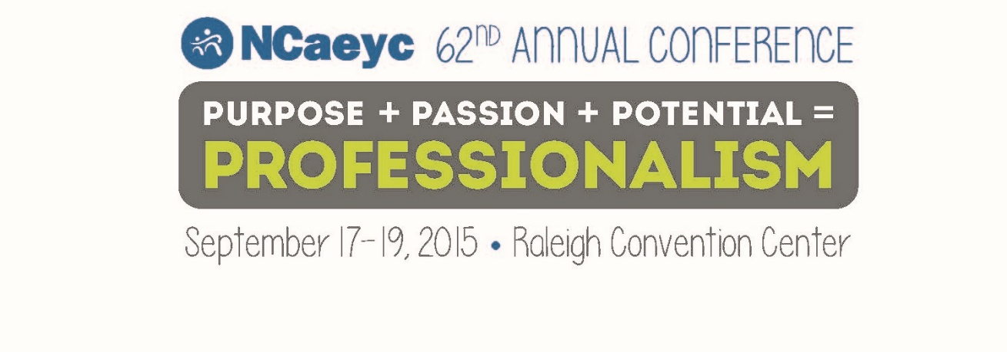
Greetings,
NCaeyc is offering twenty (20) free conference registrations for the 2015 Conference on September 17-19
at the Raleigh Convention Center. If you are interested, please complete the following application and return via email to scholarships@ncaeyc.org on Monday, July 20, 2015 by 5:00 pm. A committee consisting of NCaeyc Board members will review the applications and assign points based on the answers provided. Notifications to successful recipients will be provided by Friday, July 24, 2015.

The individuals selected for this award will receive complimentary registration to NCaeyc’s 62nd Annual Conference at the Raleigh Convention Center. All travel and related expenses are the responsibility of the recipient.

If you are not in need of this registration scholarship, or have already paid to attend the conference, we encourage you to share with friends, colleagues, and others who would benefit from this scholarship.

Sincerely,
NCaeyc Conference Committee

NCaeyc 2015 Conference Scholarship Application
Date Submitted:________________________
Applicant Name:_________________________________________________________________
Address:__________________________________________________________________________
County:____________________________________________________
Email:_______________________________ Phone:______________________________
This is my first NCaeyc conference: yes_______ no_______
I am currently a member of NCaeyc yes_____ no_______ my ID number is #______________
I have attended an NAEYC national conference: yes:____ no:_____ Where and year attended:_______
I have worked in the field of early childhood for (check one):
____ (0-3 years) ____ (4 – 7 years) ____ 7-10 years) ____ (over 11 years)
I currently work at:
____ Licensed child care center _____Licensed Family Care Home _____ Head Start _____ Public School System
_____ Higher Education _____ Other (please explain)_______________________________________________
My current title at my employment is: ______________________________________________________
If selected, I will cover any additional expenses by:
_______ work place assistance ______ self pay _______ fundraisers ______ other (please explain)

Any additional information you would like the committee to consider:____________________________________
_____________________________________________________________________________________________
______________________________________________________________________________________________
_______________________________________________________________________________________________
_____________________________________________________________________________________
Office Use only:
Date received:_______
Total Points Received:________________

